**ORU_GE Centricity IDX_TheraDoc Requirements**

**Version 1.2**

**Prepared By: Art Schwartz & Lois Whitley**

**Date: 5/25/2017**

Document Control 3

Resources 3

Project Distribution List 3

Document Version Control 3

1. Introduction 4

1.1 Purpose 4

1.2 Project Scope 4

1.3 Terminology Standards 4

1.3.1 Acronyms 4

1.3.2 Glossary 4

1.4 Document References 4

2. Diagram 5

3. Requirements 6

3.1 Functional Requirements 6

3.2 Non-Functional Requirements 6

3.3 Messaging Protocols 6

3.3.1 Inbound to the BayCare Cloverleaf 6

3.3.2 Outbound to the Vendor 7

3.3.3 Inbound From BayCare RIS 8

4. HL7 Messaging 8

4.1 Messaging Format 8

4.1.1 Segments 8

4.1*.*2 Messaging Event Types 9

4.1*.*3 Cloverleaf Configuration Files 9

4.1.4 Cloverleaf Site Location 9

4.2 Data Transformation Requirements 9

4.3 Sample Message 12

5. Testing 13

5.1. Unit Testing Scenarios 13

5.2 Integrated Testing Scenarios 13

5.3 Testing Approvals 13

5.4 Piloting 14

5.5 Approvals 14

6. Deployment / Implementation Model 14

6.1 Alerts 14

Appendix A: Risks and Concerns 15

Appendix B: Issues List 15

# **Document Control**

## Resources

|  |  |  |
| --- | --- | --- |
| **Name** | **Role** | **Email** |
| Art Schwartz | IS Integration Analyst | [Art.schwartz@baycare.org](mailto:Art.schwartz@baycare.org) |
|  |  |  |
|  |  |  |
|  |  |  |
|  |  |  |
|  |  |  |
|  |  |  |
|  |  |  |

## Project Distribution List

## Document Version Control

|  |  |  |  |
| --- | --- | --- | --- |
| **Version** | **Date** | **Modifier** | **Description** |
| V1.0 | 11/16/2016 | Lois Whitley | Originally Created |
| V1.1 | 11/16/16 | Art Schwartz | Updated Messaging Protocols |
| V1.2 | 5/25/17 | Art Schwartz | Updated |
|  |  |  |  |

# 1. Introduction

## 1.1 Purpose

The purpose of this document is to outline the Results (ORU) interface requirements for the TheraDoc application from GE Centricity IDX (RIS).

## 1.2 Project Scope

Integration for the TheraDoc application includes an ADT interface from Soarian, ADT interface from Cerner for Heights, Weights and Allergies, Orders from the Cerner PharmNet (Pharmacy) system, and results from Cerner PathNet (Lab) and GE Centricity IDX (RIS). There is a Cerner SurgiNet CCL component that passes surgical procedure information to TheraDoc, but this is a flat file and does not pass through Cloverleaf.

## 1.3 Terminology Standards

### 1.3.1 Acronyms

**ADT** – Admission, Discharge and Transfer message

**CCL** – Cerner Command Language; used to query the database and put the information in a user-friendly format

**ORU** – Observation Result/Unsolicited; this is a raw feed form Cerner PathNet or GE Centricity IDX (Radiology) – the same feed goes into Cloverleaf that comes out and goes to TheraDoc

**RDE** – Pharmacy Encoded Order Message

**RIS** – Radiology Information System

### 1.3.2 Glossary

**TheraDoc** – clinical surveillance application name

**Premier, Inc.** – vendor name

## 1.4 Document References

TDoc_Spec_Ch_06_Rad

# 2. Diagram

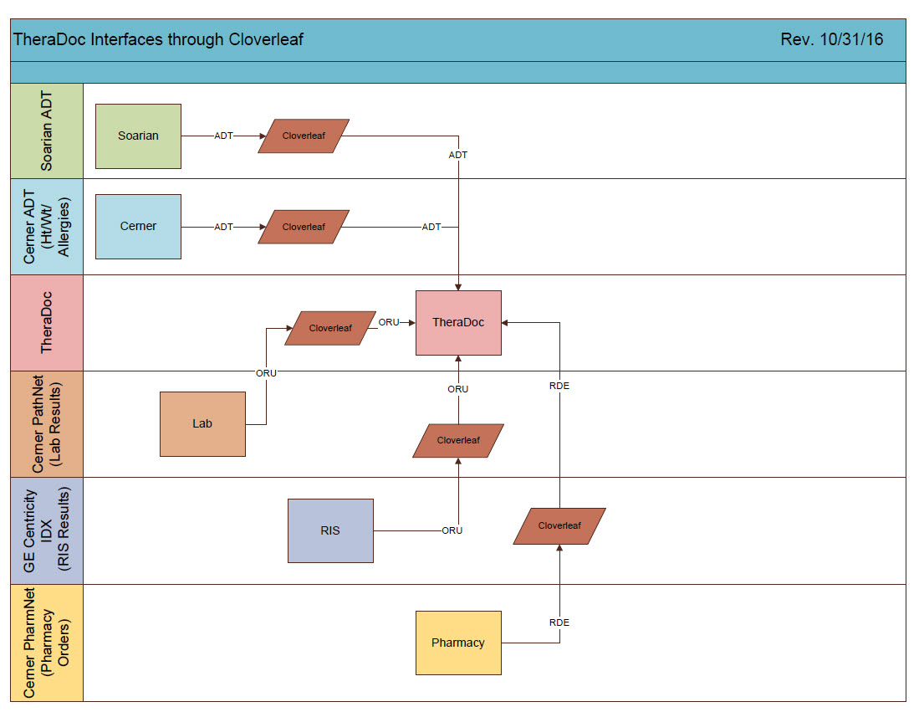

# 3. Requirements

## 3.1 Functional Requirements

Provide detail for the below functional requirements. The message transformation requirements for the components defined in this specification should be specified in section 4.2 of this document.

|  |  |  |
| --- | --- | --- |
| **Cloverleaf** |  |  |
| **Number** | **Requirement Name** | **Requirement Description** |
| FR.20XX.1.0 | Result messages greater than 4 days old are filtered. | Click here to enter text. |

## 3.2 Non-Functional Requirements

Provide concise detail for the below non-functional requirements. The below requirements must be evaluated for every project.

|  |  |  |
| --- | --- | --- |
| **Cloverleaf** |  |  |
| **Number** | **Requirement Name** | **Requirement Description** |
| NFR.20XX.1.0 | Click here to enter text. | Click here to enter text. |

## 3.3 Messaging Protocols

Below are listed the details for the messaging protocols that will be leveraged for this integration. Please see the reference document located on the Integration SharePoint server: <insert link to document here>

### 3.3.1 Inbound to the BayCare Cloverleaf

### 3.3.2 Outbound to the Vendor

|  |  |  |  |  |  |  |  |  |  |  |  |
| --- | --- | --- | --- | --- | --- | --- | --- | --- | --- | --- | --- |
|  |  |  |  | Theradoc IP and port | |  |  |  | 4/6/2016 |  |  |
| TEST |  |  |  |  |  |  |  |  |  |  |  |
|  | ADT & Allergies |  |  | Lab Results and HT & WT |  |  | Pharmacy |  |  | RAD |  |
| facility | IP | Port |  | IP | Port |  | IP | Port |  | IP | Port |
| SJH | 10.44.110.28 | 8010 |  | **10.44.110.28** | **8012** |  |  |  |  |  |  |
| SJN | 10.44.110.28 | 8035 |  | **10.44.110.28** | **8013** |  |  |  |  |  |  |
| SJS | 10.44.110.28 | 8006 |  | **10.44.110.28** | **8007** |  |  |  |  |  |  |
| SFB | 10.44.110.28 | 8004 |  | **10.44.110.28** | **8008** |  |  |  |  |  |  |
| SJW | 10.44.110.28 | 8011 |  | **10.44.110.28** | **8036** |  |  |  |  |  |  |
| WHH | 10.44.110.28 | 8015 |  | **10.44.110.28** | **8017** |  |  |  |  |  |  |
| WHW | 10.44.110.28 | 8016 |  | **10.44.110.28** | **8018** |  |  |  |  |  |  |
| MPH | 10.44.110.28 | 8019 |  | **10.44.110.28** | **8025** |  |  |  |  |  |  |
| MDU | 10.44.110.28 | 8020 |  | **10.44.110.28** | **8026** |  |  |  |  |  |  |
| MCS | 10.44.110.28 | 8021 |  | **10.44.110.28** | **8027** |  |  |  |  |  |  |
| NBY | 10.44.110.28 | 8022 |  | **10.44.110.28** | **8028** |  |  |  |  |  |  |
| BAH | 10.44.110.28 | 8023 |  | **10.44.110.28** | **8029** |  |  |  |  |  |  |
| SAH | 10.44.110.28 | 8024 |  | **10.44.110.28** | **8030** |  |  |  |  |  |  |
| BRM | 10.44.110.28 | 8031 |  | **10.44.110.28** | **8032** |  |  |  |  |  |  |
| All facilities |  |  |  |  |  |  | 10.44.110.28 | 8005 |  | 10.44.110.28 | 8003 |
|  |  |  |  |  |  |  |  |  |  |  |  |
|  |  |  |  |  |  |  |  |  |  |  |  |
| PROD |  |  |  |  |  |  |  |  |  |  |  |
|  | ADT & Allergies |  |  | Lab Results and HT & WT |  |  | Pharmacy |  |  | RAD |  |
| facility | IP | Port |  | IP | Port |  | IP | Port |  | IP | Port |
| SJH | 10.44.129.56 | 9010 |  | **10.44.129.56** | **9012** |  |  |  |  |  |  |
| SJN | 10.44.129.56 | 9009 |  | **10.44.129.56** | **9013** |  |  |  |  |  |  |
| SJS | 10.44.129.56 | 9006 |  | **10.44.129.56** | **9007** |  |  |  |  |  |  |
| SFB | 10.44.129.56 | 9004 |  | **10.44.129.56** | **9008** |  |  |  |  |  |  |
| SJW | 10.44.129.56 | 9011 |  | **10.44.129.56** | **9014** |  |  |  |  |  |  |
| WHH | 10.44.129.56 | 9015 |  | **10.44.129.56** | **9017** |  |  |  |  |  |  |
| WHW | 10.44.129.56 | 9016 |  | **10.44.129.56** | **9018** |  |  |  |  |  |  |
| MPH | 10.44.129.56 | 9019 |  | **10.44.129.56** | **9025** |  |  |  |  |  |  |
| MDU | 10.44.129.56 | 9020 |  | **10.44.129.56** | **9026** |  |  |  |  |  |  |
| MCS | 10.44.129.56 | 9021 |  | **10.44.129.56** | **9027** |  |  |  |  |  |  |
| NBY | 10.44.129.56 | 9022 |  | **10.44.129.56** | **9028** |  |  |  |  |  |  |
| BAH | 10.44.129.56 | 9023 |  | **10.44.129.56** | **9029** |  |  |  |  |  |  |
| SAH | 10.44.129.56 | 9024 |  | **10.44.129.56** | **9030** |  |  |  |  |  |  |
| BRM | 10.44.129.56 | 9031 |  | **10.44.129.56** | **9032** |  |  |  |  |  |  |

### 3.3.3 Inbound From BayCare RIS

Test

Port Number: 13057

IP Address: 10.5.250.203

Prod

Port Number: 13057

IP Address: 10.5.250.201

# 4. HL7 Messaging

## 4.1 Messaging Format

### 4.1.1 Segments

The segments utilized for this interface are:

MSH

PID

PV1

ORC

OBR

OBX

*Message Construction Notes:*

*[Square Brackets] – Optional*

*{Curly Brackets} – Repeatable*

*MSH – Message Header*

*PID – Patient ID segment*

*PV1 – Patient Visit segment*

*ORC – Common Order segment*

*OBR – Observation Request segment*

*OBX – Observation/Result segment*

*[{ – Start of optional, repeatable group*

*}] – End of optional, repeatable group*

### 4.1*.*2 Messaging Event Types

Below are the messages types necessary for this integration and supported by TheraDoc and Soarian.

|  |  |
| --- | --- |
| **Event Type** | **Description** |
| R01 | Unsolicited transmission of an observation message |

### 4.1*.*3 Cloverleaf Configuration Files

This is a raw route with no translate

### 4.1.4 Cloverleaf Site Location

theradoc_25

## 4.2 Data Transformation Requirements

Results from RIS is a raw feed to TheraDoc with No translate or transformation of data.

| **Field Description** | **HL7 Field Loc.** | **Required Y/N** | **Data Type** | **Length** | **Notes** |
| --- | --- | --- | --- | --- | --- |
| Message Header | MSH |  |  |  | Pathcopy MSH |
| Sending Application | MSH.3 |  |  |  | IDX |
| Sending Facility | MSH.4 |  |  |  |  |
| Receiving Application | MSH.5 |  |  |  |  |
| Date/Time of Message | MSH.7 |  |  |  |  |
| Message Type | MSH.9 |  |  |  | i.e ORU^R01 |
| Message Control ID | MSH.10 |  |  |  |  |
| Patient Identification | PID |  |  |  | Primary means of identifying patients in TheraDoc |
| Set ID | PID.1 |  |  |  |  |
| Patient ID (External ID) | PID.2 |  |  |  | Person Identifier in TheraDoc |
| Patient ID (Internal ID) | PID.3 |  |  |  | MRN; matches value against TheraDoc patient table; required to link the report to a patient |
| Alternate Patient ID | PID.4 |  |  |  |  |
| Patient Name | PID.5 |  |  |  | FamilyName^GivenName |
| Date/Time of Birth | PID.7 |  |  |  | YYYYMMDD; calculates current age of patient |
| Sex | PID.8 |  |  |  | M=Male  F=Female  U=Unknown |
| Patient Account Number | PID.18 |  |  |  | Primary identifier for encounters; matches against TheraDoc encounter table; required to link the report to a patient visit |
| Social Security Number | PID.19 |  |  |  |  |
| Patient Visit | PV1 |  |  |  |  |
| Set ID | PV1.1 |  |  |  |  |
| Patient Class | PV1.2 |  |  |  |  |
| Attending Doctor | PV1.7 |  |  |  | ProvNum^FamilyName^GivenName^ |
| Admit Date/Time | PV1.44 |  |  |  | YYYYMMDDHHMM |
| Discharge Date/Time | PV1.45 |  |  |  | YYYYMMDDHHMM |
| Common Order | ORC |  |  |  |  |
| Order Control | ORC.1 |  |  |  |  |
| Placer Order Number | ORC.2 |  |  |  |  |
| Filler Order Number | ORC.3 |  |  |  |  |
| Ordering Provider | ORC.12 |  |  |  |  |
| Observation Request | OBR |  |  |  |  |
| Set ID | OBR.1 |  |  |  |  |
| Placer Order Number | OBR.2 |  |  |  |  |
| Filler Order Number | OBR.3 |  |  |  | Unique number to identify order |
| Universal Service Identifier | OBR.4 |  |  |  | Identifies the order/test code and description, or the name/type of the transcription document (Discharge Summary, Office Visit Note, etc.) |
| Observation Date/Time | OBR.7 |  |  |  | Contains the date/time of the report or transcription |
| Relevant Clinical Information | OBR. 13 |  |  |  |  |
| Ordering Provider | OBR.16 |  |  |  | ProvNum^FamilyName^GivenName |
| Results Report/Status Change Date/Time | OBR.22 |  |  |  |  |
| Result Status | OBR.25 |  |  |  |  |
| Quantity/Timing | OBR.27 |  |  |  |  |
| Reason for Study | OBR.31 |  |  |  |  |
| Principal Result Interpreter | OBR.32 |  |  |  |  |
| Technician | OBR.34 |  |  |  |  |
| Transcriptionist | OBR.35 |  |  |  |  |
| Observation Result | OBX |  |  |  |  |
| Set ID | OBX.1 |  |  |  |  |
| Value Type | OBX.2 |  |  |  |  |
| Observation Identifier | OBX.3 |  |  |  | Identifier^Text^^Alternate Identifier^Alternate Text |
| Observation Value | OBX.5 |  |  |  | Value of OBX.5 of each OBX segment provides one line of text in the report |
| Observation Result Status | OBX.11 |  |  |  |  |
| Date/Time of Observation | OBX.14 |  |  |  |  |

## 4.3 Sample Message

**Results from Radiology to TheraDoc (Raw feed - same in and out)**

MSH|^~\&|IDX|SAH|||20161107092720||ORU^R01|360707393|P|2.3

PID||103879273|005668100^10^0^^^SAH||IYCGTOJ^XUGJCST^Z^^^||19510203000000|F||||||||||9720942550^^^|777-77-7777

PV1|1|D|||||MS027517^Solyar^Alla^^^^^1265762108|||||||||||||||||||||||||||||||||||||20140403060000|20140410094500

ORC|RE|4225650819|40007534|||||||||MS027517^Solyar^Alla^^^^^1265762108^727^573^0074^

OBR|1|4225650819|40007534|CGASGTPLC^CT GI GASTRIC PERC G TUBE PLACEMENT|||20150114170500||||||ENDO SINUS SURGERY|||MS027517^Solyar^Alla^^^^||||||20161107092700|||F||^^90^20150114170500^^||||test|MS006147^Egan^Thomas^J^^^M.D.SAHC Radiologist|~|^Johnson^Cynthia^^^^TEST RAD|^Wilson^Candy^^^^Sr. Systems Analyst

OBX|1|FT|CGASGTPLC&GDT||TECHNIQUE:  Axials 5 mm CT slices of the abdomen and pelvis without ||||||F|||20161107092700

OBX|2|FT|CGASGTPLC&GDT||and with IV contrast_followed by 2D coronal reformats. ||||||F|||20161107092700

OBX|3|FT|CGASGTPLC&GDT||||||||F|||20161107092700

OBX|4|FT|CGASGTPLC&GDT||||||||F|||20161107092700

MSH|^~\&|IDX|SAH|||20161107092720||ORU^R01|360707393|P|2.3

PID||103879273|005668100^10^0^^^SAH||IYCGTOJ^XUGJCST^Z^^^||19510203000000|F||||||||||9720942550^^^|777-77-7777

PV1|1|D|||||MS027517^Solyar^Alla^^^^^1265762108|||||||||||||||||||||||||||||||||||||20140403060000|20140410094500

ORC|RE|4225650819|40007534|||||||||MS027517^Solyar^Alla^^^^^1265762108^727^573^0074^

OBR|1|4225650819|40007534|CGASGTPLC^CT GI GASTRIC PERC G TUBE PLACEMENT|||20150114170500||||||ENDO SINUS SURGERY|||MS027517^Solyar^Alla^^^^||||||20161107092700|||F||^^90^20150114170500^^||||test|MS006147^Egan^Thomas^J^^^M.D.SAHC Radiologist|~|^Johnson^Cynthia^^^^TEST RAD|^Wilson^Candy^^^^Sr. Systems Analyst

OBX|1|FT|CGASGTPLC&GDT||TECHNIQUE:  Axials 5 mm CT slices of the abdomen and pelvis without ||||||F|||20161107092700

OBX|2|FT|CGASGTPLC&GDT||and with IV contrast_followed by 2D coronal reformats. ||||||F|||20161107092700

OBX|3|FT|CGASGTPLC&GDT||||||||F|||20161107092700

OBX|4|FT|CGASGTPLC&GDT||||||||F|||20161107092700

# **5. Testing**

## 5.1. Unit Testing Scenarios

|  |  |
| --- | --- |
| **Scenario** | **Expected Result** |
|  |  |
|  |  |
|  |  |
|  |  |
|  |  |

## 5.2 Integrated Testing Scenarios

|  |  |
| --- | --- |
| **Scenario** | **Expected Result** |
|  |  |
|  |  |
|  |  |
|  |  |
|  |  |
|  |  |

## 5.3 Testing Approvals

|  |  |  |  |
| --- | --- | --- | --- |
| **Testing Phase** | **Date** | **Department** | **Team Member** |
| PH1.UNIT |  |  |  |
| PH1.INTEGRATED |  |  |  |

### 

## 5.4 Piloting

List the facilities and associated networks in scope for pilot testing.

## 5.5 Approvals

|  |  |  |  |
| --- | --- | --- | --- |
| **Testing Phase** | **Date** | **Department** | **Team Member** |
| PH1.0 |  |  |  |
|  |  |  |  |
|  |  |  |  |

# 6. Deployment / Implementation Model

Provide the detail as to how to deploy the solution defined in the IDBB from both the BAYCARE and vendor perspective.

## 6.1 Alerts

Are you going to need alerting on this connection?

|  |  |
| --- | --- |
| Yes |  |
| No |  |

If the answer is yes, please complete the table below:

|  |  |  |  |
| --- | --- | --- | --- |
| **Site Name** | **Hours of Support** | **Distribution Group** | **Comments** |
|  |  |  |  |
|  |  |  |  |

# Appendix A: Risks and Concerns

|  |  |  |  |  |  |  |  |  |
| --- | --- | --- | --- | --- | --- | --- | --- | --- |
| **Project Name** |  |  | | |  |  |  |  |
| **Number** | **Risk / Concern** | **Comment** | **Mitigation** | | |  |  |  |
| RC.2013.1.0 |  |  | |  | |  |  |  |

# Appendix B: Issues List

This is a dynamic list of the open issues related to the IDBB that remain to be solved, including but not limited to TBDs, pending decisions, information needed, conflict awaiting resolution, and the like.

|  |  |  |  |  |  |  |  |  |
| --- | --- | --- | --- | --- | --- | --- | --- | --- |
| **Project Name** |  |  | | |  |  |  |  |
| **Number** | **Issue** | **Comment** | **Fix** | | |  |  |  |
| I.2013.1.0 |  |  | |  | |  |  |  |

* End of document